

Approach to Market
To establish Contract for Procurement of the Scrivener Dam Independent Technical Advisor - 2026-2029
Reference ID: A26/6
UNSPSC: 81100000 Professional engineering services
This Approach to Market (ATM) is for the provision of a suitably qualified and experienced consultant to provide expert and independent technical advice for the dam safety management of Scrivener Dam.
The Commonwealth of Australia as represented by National Capital Authority (the Customer) is seeking submissions for the provision of the consultancy services (the Requirement) as described in this ATM comprising:
- this CCS ATM, including the Statement of Requirement
- the CCS ATM Response Form
- the CCS ATM Annexes (if any)
- the Commonwealth ATM Terms
- the Additional Contract Terms (if any)
- the Commonwealth Contract Terms
- the Commonwealth Contracting Suite Glossary and Interpretation.
In submitting a response, Potential Suppliers are required to comply with all requirements set out in the Commonwealth Approach to Market Terms (a copy of which is included in this document), and if successful, agree to enter into a contract which incorporates the Commonwealth Contract Terms available at https://www.finance.gov.au/government/procurement/commonwealth-contracting-suite-ccs#ccs-terms.

*Tenderers are to note that the Commonwealth ATM Terms are inserted as an image and may not be recognised as searchable text.

The Selling to Government website provides information to help businesses understand how to sell to the Australian Government. If you have any general questions about how the Australian Government procures goods and services, please contact the Selling to Government team at sellingtogov@finance.gov.au.
For questions relating specifically to this ATM, please contact the ATM Contact Officer set out at A.A.5(a).
Statement of Requirement
A.A.1 Key Information and Dates
Approach to Market
Event | Details
ATM Closing Date | Thursday, 13 August 2026
ATM Closing Time | 2:00 pm ACT local time
Industry Briefing | Unless otherwise notified by an addendum, there are no industry briefing sessions for this ATM.
Site Inspection | Unless otherwise notified by an addendum, there are no site inspections for this ATM.
Question Closing Date and Time | Questions will be permitted up until 5:00 pm Thursday, 6 August 2026, ACT local time.
Minimum Content and Format Requirements | For a Potential Supplier’s Response to be eligible for consideration, in addition to the matters addressed in A.B.4.2 of the Commonwealth ATM Terms.
Conditions for Participation | Conditions for Participation  The Customer will exclude from participation any Potential Supplier that does not demonstrate compliance with:  - The Respondent meets the definition of an Australian or New Zealand business  https://www.finance.gov.au/government/procurement/defining-australian-business-commonwealth-procurement/guidance-definition-australian-or-new-zealand-business
Proposed Contract
Event | Details
Proposed Start Date: | Thursday, 1 October 2026
Contract Term: | The Contract will remain in force for a period of 3 Years from the date the Contract is entered into.
Contract Extension Option | The contract will include the following extension option(s):  - One (1) optional extension up to 1 year, at the discretion of the NCA.

A.A.2 The Requirement
The National Capital Authority (NCA) is seeking to engage a suitably qualified and experienced consultant for Independent Technical Advisor (ITA) services at Scrivener Dam. The services include regular audits to assess NCA’s compliance to the Dam Safety Management Plan, and the provision of independent technical advice for the dam safety management of Scrivener Dam.
Scrivener Dam:
Scrivener Dam is located on the Molonglo River, in Canberra, and forms Lake Burley Griffin. It is an asset of National importance and is classified as a Large Dam with a 'High C' Consequence Category (in the Hydrology, Dam Break and Consequence Category assessment undertaken by SMEC in 2021) in accordance with the Australian National Committee on Large Dams (ANCOLD) definitions and guidelines.
Dam Safety Management Plan (DSMP):
The NCA does not currently come under the jurisdiction of a dam safety regulator within the Utilities Technical Regulator and has therefore implemented a self-regulated approach to dam safety. It has adopted a Dam Safety Code which specifies the actions to be taken to achieve this position. The NCA’s Dam Safety Code has been developed in consideration of contemporary good practice including the ACT Dam Safety Code.
In 2014, the ACT Government enacted the Utilities (Technical Regulation) Act 2014 and Utilities (Dam Safety Code) Determination 2014, with the intent of regulating all notifiable dams in the ACT. Legal advice was obtained through the Australian Government Solicitors in 2015 which confirmed that the ACT Dam Safety Code was not enforceable on the Commonwealth and therefore, Scrivener Dam. On 13 July 2015, the regulator acknowledged NCA’s intent on remaining self-regulated, but was including the dam in the ACT Dams Register as a listed dam.
The Dam Safety Management Plan (DSMP) is updated annually. The DSMP encompasses the Dam Safety Policy, Dam Safety Code and details actions, and responsibilities required to manage and operate Scrivener Dam in accordance with the relevant codes and guidelines. The hierarchy of the DSMP is illustrated below in Figure 1. The DSMP ensures that the NCA’s dam safety management of Scrivener Dam is in accordance with contemporary good practice, including guidelines set out by ANCOLD.
Figure 1 – Hierarchy of the DSMP
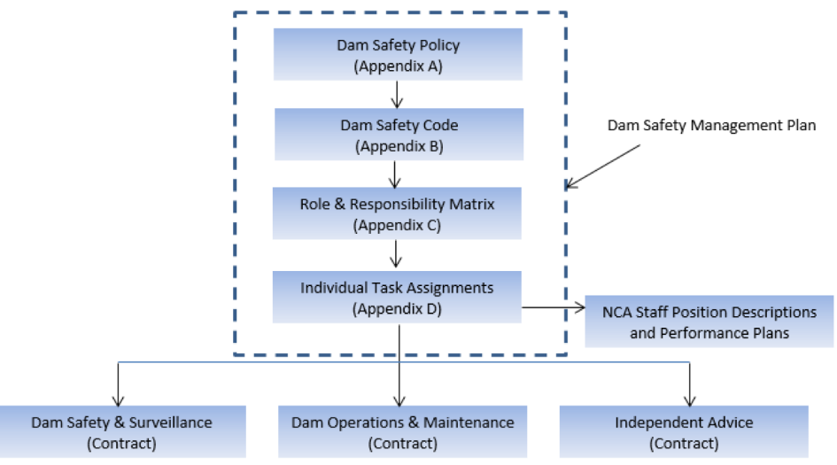

General requirements:
The successful Supplier will be suitably qualified and have sound knowledge of relevant ANCOLD and ICOLD guidelines, and Australian Standards as appropriate and will support contemporary good practice for dam safety management as applied to Scrivener Dam.
The successful Supplier will provide technical advice and support regarding dam safety management for Scrivener Dam. The ITA will also be responsible for the Annual Validation Audits and 5-yearly Functional Audit (due 2029) of the DSMP to assess the performance of the NCA against the requirements of the individual task assignments specified in the DSMP. There are currently (as of August 2025), twenty-three individual task assignments specified in the DSMP, included at ATTACHMENT A.
The successful Supplier is to provide technical advice to review the following elements of the Plan and provide support when required:
- Dam Safety Management Policy
- Dam Safety Code
- Dam Safety Governance
- Dam Safety Culture
- Industry Awareness within the NCA
- Review Design Reviews and Risk Assessments
- Establish Dam Safety Requirements for Operations, Maintenance and Surveillance
- Other technical matter
Deliverables:
- Annual Validation Audit of the DSMP
The Supplier will be required to undertake annual Validation Audits of the DSMP by 31 August each year to assess the performance of the NCA against the requirements of the DSMP and to confirm the required activities have been completed to an appropriate technical standard. A Validation Audit is an audit of technical quality and adequacy of each completed task. These audits must be undertaken by individuals with necessary technical skills to critically examine and review each task output against defined or industry standards. For example, this audit will consider key dam safety documents such as the Dam Safety Emergency Plan and will review that its content is consistent with that required by industry standards (ANCOLD Guidelines on Dam Safety Management), and that the technical details against each element of the Dam Safety Emergency Plan are sound and logical from an engineering and dam safety perspective. This review is general commenced in June each year and a draft report provided by July and finalised by 31 August each year. The NCA will provide nominated documents created during each financial year in a digital form for review.

Estimated Level of Effort:
To assist tenderers preparing their submissions, the Customer advises that, based on similar requirements, the estimated level of effort to complete the Annual Validation Audit is approx. 110 hours, including document review, stakeholder engagement, analysis, and reporting.
The actual level of effort may vary depending on the number, quality, and complexity of documents provided, as well as the personnel engaged, their experience, and the efficiency of the audit approach and methodology applied.

- Functional Audit of the DSMP
Functional Audits are undertaken at least every 5 years or when there is a significant change in dam industry practice or if there is a significant change in the NCA’s operational environment. The last Functional Audit of the DSMP was completed in June 2024 and will be required during the Contract period in August 2029. These audits examine whether all necessary tasks are appropriately specified, including actual delivery requirements, timing and frequencies. They are designed to identify if any significant changes have occurred in either the individual operating environment or in the broader industry which would require a change in activities or details. For example, a Functional Audit would review all tasks, outputs, responsibilities, and frequencies outlined in this Dam Safety Management Plan and, in particular, the Responsibility Matrix and Individual Task Assignments (ATTACHMENT A). The Functional Audit includes an independent audit of the dam surveillance program as detailed below. The audit is to be undertaken in accordance with the requirements of ISO 19011:2018 Guidelines for Auditing Management Systems.

Estimated Level of Effort:
To assist tenderers preparing their submissions, the Customer advises that, based on similar requirements, the estimated level of effort to complete the 5-yearly Functional + Annual Validation Audit is approx. 175 hours, reflecting its broader scope, system-level review, and increased volume and complexity of documentation.
The actual level of effort may vary depending on the number, quality, and complexity of documents assessed, as well as the personnel engaged, their experience, and the efficiency of the audit approach and methodology applied.

- Independent Audit of the Dam Surveillance Program
The NCA is required to obtain an independent audit of the dam’s surveillance program every 10 years, as prescribed by Section 5.7 of the ANCOLD ‘Guidelines on Dam Safety Management’ (2003). The next independent audit of the dam’s surveillance program is scheduled to be completed in 2034, this audit is excluded from the scope of work.

- Independent Technical advice
The supplier will be required to provide independent technical advice to the NCA regarding dam safety related matters. The cost for advice will be based on hourly rates specified in the Contract with deliverables and reporting agreed to with the NCA on a case-by-case basis.
A.A.2(a) Commonwealth Supplier Code of Conduct
The Commonwealth expects its suppliers to conduct themselves with high standards of ethics such that they consistently act with integrity and accountability.
If awarded a Contract, the Supplier must agree to comply with the Commonwealth Code of Conduct (Code) in accordance with the Commonwealth Contract Terms [Clause C.C.23].
Clause C.C.23 requires the Supplier to comply with the Code when performing its obligations under the Contract, and to ensure its personnel and Subcontractors comply with the Code. The clause also requires the Supplier to proactively monitor and assess compliance with the Code, and to notify the Customer immediately of any breach of the Code.
In accordance with the Commonwealth ATM Terms [Clause A.B.10], where requested by the Customer, Potential Suppliers should provide information demonstrating that they have appropriate policies, frameworks, or similar, in place to comply with the Code.
Further information on the Code can be found at: https://www.finance.gov.au/government/procurement/commonwealth-supplier-code-conduct
A.A.2(b) Standards
Potential Suppliers must ensure that any goods and services proposed are capable of complying with all applicable Australian standards and any Australian and international standards specified in this Statement of Requirement. Potential Suppliers should note that they may be required to enable the Customer, or an independent assessor, to conduct periodic audits to confirm compliance with those standards.
Web Content Accessibility
The Supplier must ensure that any website, associated material and/or online publications (where applicable) complies with the Web Content Accessibility Guidelines available at: https://www.w3.org/WAI/intro/wcag.
A.A.2(c) Security Requirements
All personnel are to provide a Nationally Coordinated Criminal History Check (NCCHC), through an ACIC-accredited body, for submission to the NCA with the Transition In plan.
The cost of obtaining each Nationally Coordinated Criminal History Check will be borne by the Supplier.
A.A.2(d) Work Health and Safety
Prior to commencement of the Contract, the Customer’s Contract Manager and the Supplier’s Contract Manager will identify any potential work health and safety (WHS) issues anticipated to arise during the term of the contract and assign management of each issue identified to the party best able to manage it. For all issues assigned to the Supplier, the Supplier will provide the Customer with a WHS plan for approval and no work will commence until the plan is approved unless agreed in writing by the Customer.
Throughout the Contract Term, the Customer and the Supplier will proactively identify and cooperate to manage any WHS issues that arise.
Prior to commencement of the Contract, the Customer’s Contract Manager and the Supplier’s Contract Manager will identify any potential work health and safety (WHS) issues anticipated to arise during the term of the contract and assign management of each issue identified to the party best able to manage it.
Throughout the Contract Term, the Customer and the Supplier will proactively identify and cooperate to manage any WHS issues that arise.
A.A.2(e) Delivery and Acceptance
The Customer must accept or reject any deliverables under the Contract in accordance with the Commonwealth Contract Terms [Clause C.C.11].
Milestone Description | Delivery Location | Due Date
2026-2027 Annual Validation Audit of the DSMP | Email To james.callan@nca.gov.au | 31/08/2027
2027-2028 Annual Validation Audit of the DSMP | Email to james.callan@nca.gov.au | 31/08/2028
2028-2029 5 yearly Functional Audit | Email to james.callan@nca.gov.au | 31/08/2029
2029-2030 Annual Validation Audit of the DSMP (Subject to Contract Extension) | Email to james.callan@nca.gov.au | 31/08/2030
Ad hoc technical advice | Email to james.callan@nca.gov.au | As required
A.A.2(f) Meetings
The Supplier will be required to attend meetings as follows:
Meeting Type | Position Required |  | Frequency | Mode | Location
Project start up | Independent Technical Advisor |  | Once | Teleconference | n/a
Ad hoc Meetings | Independent Technical Advisor |  | As required (to be reimbursed under the contract schedule of rates) | TBC | n/a
A.A.2(g) Facilities and Assistance Offered by the Customer
The Customer will not make any facilities or assistance available to the Supplier.
A.A.2(h) Customer Material
The Customer will provide the Supplier with electronic copies of the Dam Safety Management Plan (DSMP) and any other relevant documentation required for each audit. These documents will be provided in a digital format to support the Supplier in preparing for and undertaking the audits.
A.A.2(i) Australian business requirement
The Supplier must ensure that they are an ‘Australian business’ for the purpose of paragraph 5.4 of the Commonwealth Procurement Rules.

A.A.3 ATM Distribution
AusTender Distribution
This ATM and any updates are subject to the AusTender Terms of Use. Any updates to this ATM will be distributed via AusTender.
AusTender is the Australian Government’s procurement information system. Access to and use of AusTender is subject to the AusTender Terms of Use. In participating in this ATM process, Potential Suppliers must comply with the AusTender Terms of Use and any applicable instructions, processes, procedures and recommendations as advised on AusTender.
A.A.4 Lodgement of Responses
AusTender
Responses must be lodged electronically via AusTender before the Closing Time and in accordance with the Response lodgement procedures set out in this ATM documentation and on AusTender.
All queries for technical or operational support must be directed to the AusTender Help Desk. Contact details are available on the Contact Us page of the AusTender website.
The Closing Time will be displayed on the relevant AusTender webpage together with a countdown clock that displays, in real time, the time left until Closing Time (for more information refer to AusTender Terms of Use).
For the purpose of determining whether a Response has been lodged before the Closing Time, the countdown clock will be conclusive.
Response File Format, Naming Convention and Size
The Customer will accept Responses lodged in the following formats:
- Microsoft Word (.docx)
- Microsoft Excel (.xlsx)
- PDF (.pdf)
The Response file name/s should:
- incorporate the Potential Supplier’s full legal organisation name; and
- reflect the various parts of the bid they represent (where the Response comprises multiple files).
Response files must not exceed a combined file size of 10 megabytes per upload.
Responses must be completely self-contained. No embedded files can be included. No hyperlinked or other material may be incorporated by reference.

A.A.5 Customer’s Contact Officers
A.A.5(a) ATM Contact Officer
For all matters relating to this ATM, the Contact Officer is:
Name/Position: James Callan, Manager Lake and Dam
Email Address: james.callan@nca.gov.au
Telephone: +61 2 6272 2974
Note: Question Closing Date and Time are set out at item A.A.1 [Key Information and Dates].
A.A.5(b) Complaints Handling
Complaints relating to this ATM should be directed to:
Name/Position: | Hamid Heydarian
Email Address: | Procurement.review@nca.gov.au
Information relating to the handling of complaints is available on the Customer’s website at: https://www.nca.gov.au/contact-us.
If your issue is not resolved refer https://www.finance.gov.au/business/procurement/complaints-handling-charter-complaints for more information relating to complaints.

Additional Contract Terms
An executed contract will incorporate the Commonwealth Contract Terms and also the following Additional Contract Terms:
A.C.1 Intellectual Property
The Customer owns the Intellectual Property Rights in the Material created under the Contract.
To the extent the Supplier or a third party holds any Intellectual Property Rights in any existing Material, the Supplier hereby agrees to licence the Customer to enable the Customer to exercise full rights and interests in the Intellectual Property Rights in any Material provided under the Contract. The Supplier agrees to create, execute or sign any documents and perform all acts which may be necessary to allow the use of those rights by the Customer for any purpose.
The Customer grants to the Supplier a non-exclusive, non-transferable, irrevocable, royalty-free licence for the Contract Term to exercise the Intellectual Property Rights in the Material for the sole purpose of fulfilling its obligations under the Contract. The licence in this clause is subject to any conditions or limitations of third parties that the Customer notifies to the Supplier.
Intellectual Property Rights in Goods provided under the Contract or pre-existing Intellectual Property of the Supplier, set out below (if any), will not change as a result of the Contract.
A.C.2 Payment Terms
The Customer must pay the amount of a Correctly Rendered Invoice to the Supplier within twenty (20) calendar days after receiving it, or if this day is not a Business Day, on the next Business Day.

A.C.3 Liability Cap for Supplier
The Supplier’s liability to pay any amount to the Customer arising out of the Contract is limited. This limit will not apply in relation to any liability arising out of or relating to:
- personal injury (including sickness or death of a person);
- unlawful or illegal acts;
- loss or, damage to, tangible property;
- any breach of, or claims relating to, intellectual property rights, confidentiality, privacy or security obligations;
- the provision of any Goods under the Contract.
Type | Amount | Period
Public Liability | $20 million per occurrence | Until 5 years after the expiry or earlier termination of this Contract
Professional Indemnity | $10 million per claim | Until 5 years after the expiry or earlier termination of this Contract
Worker’s Compensation | As required by law | Until expiry or earlier termination of this Contract

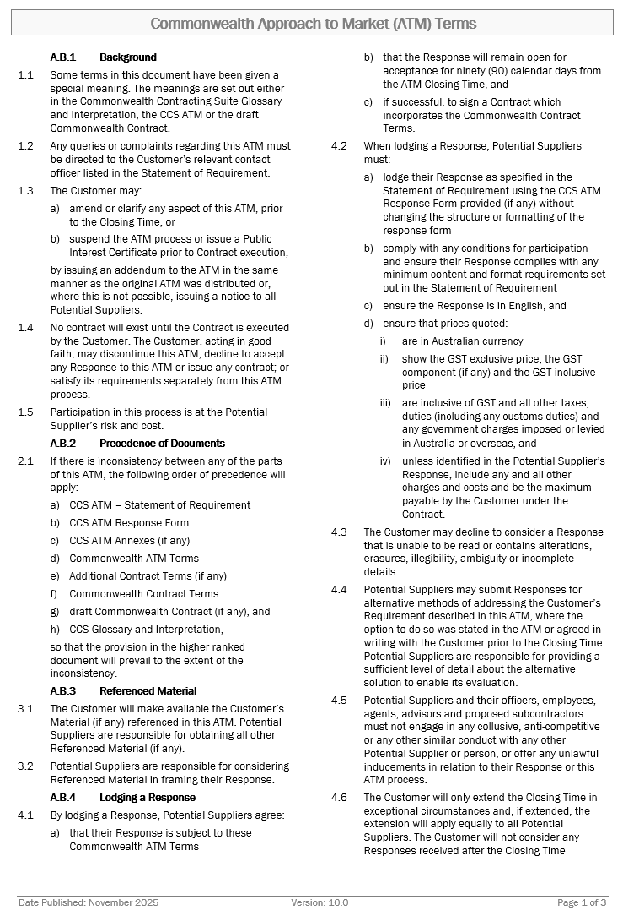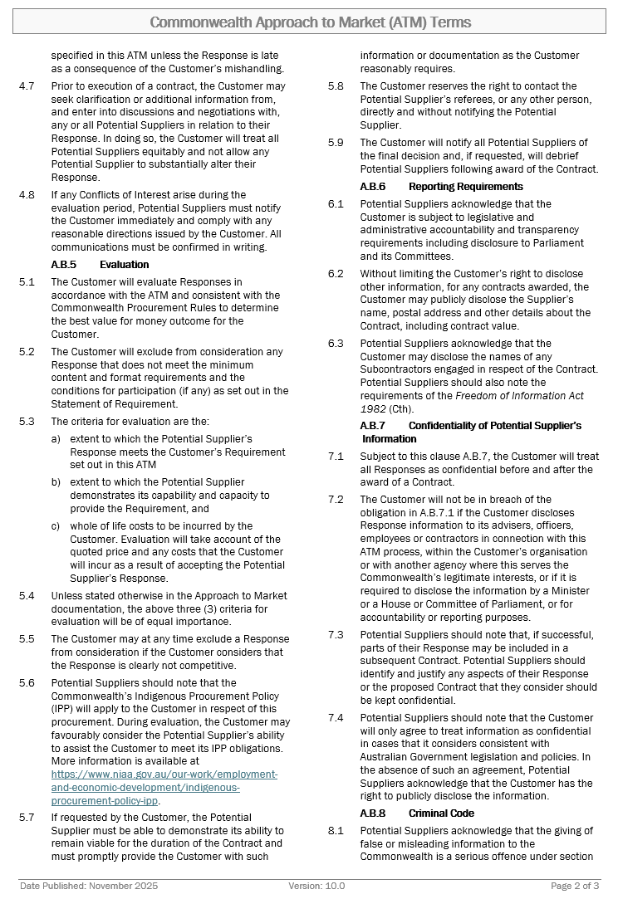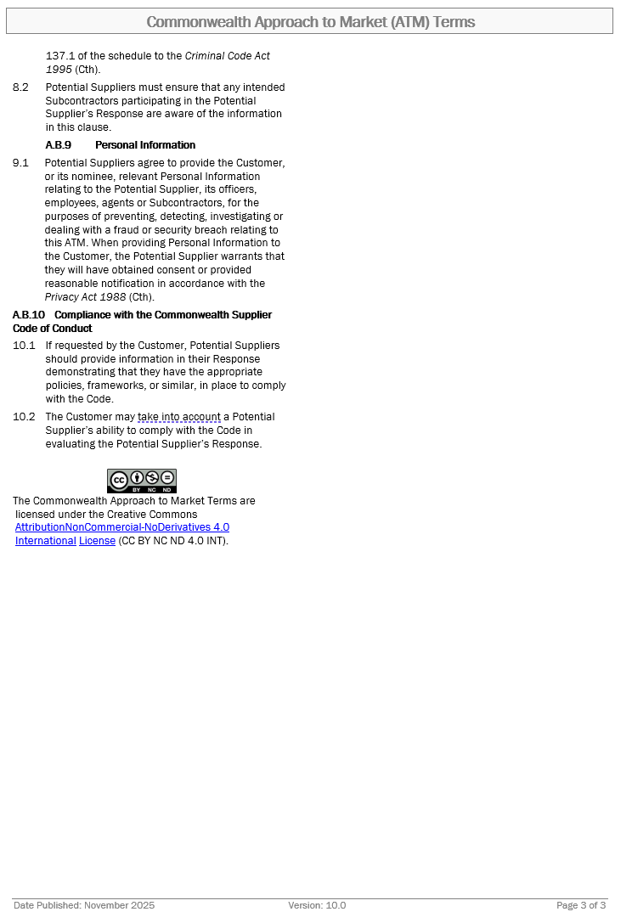
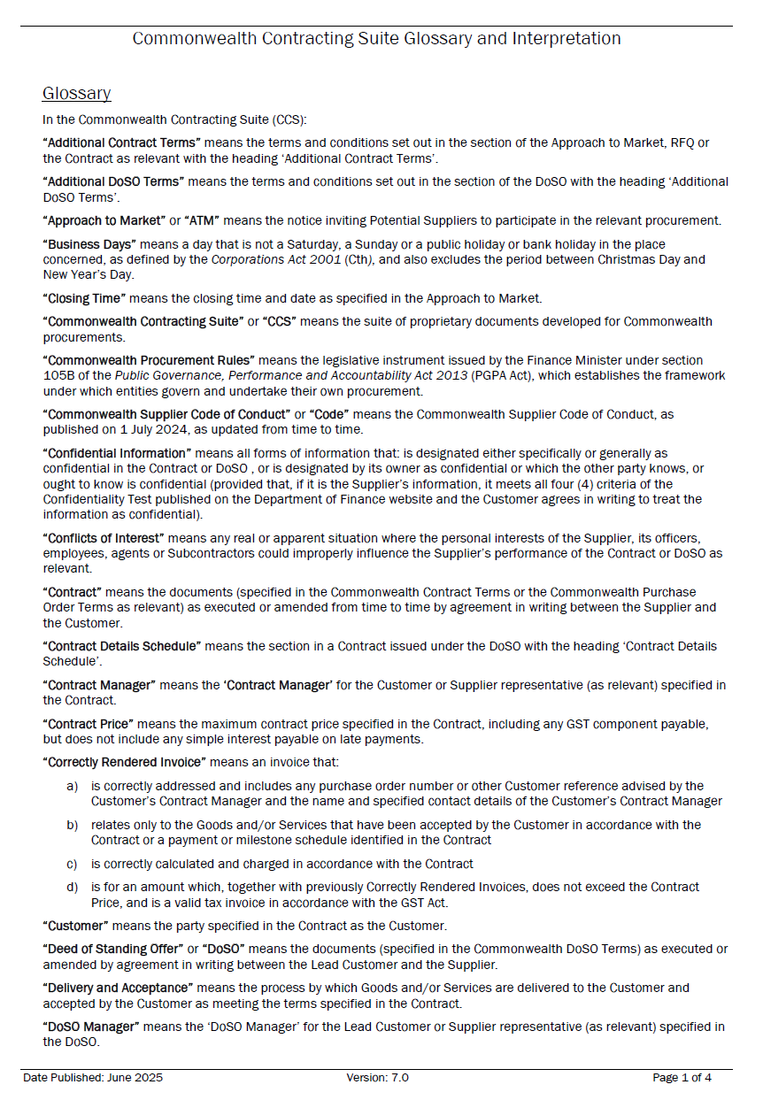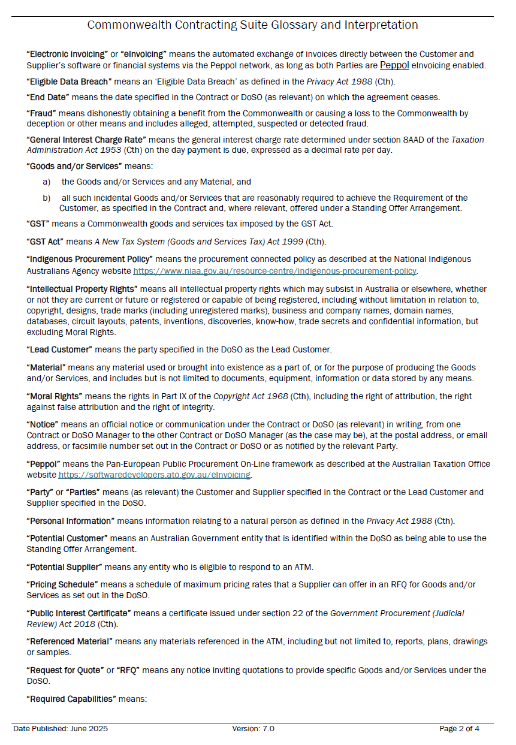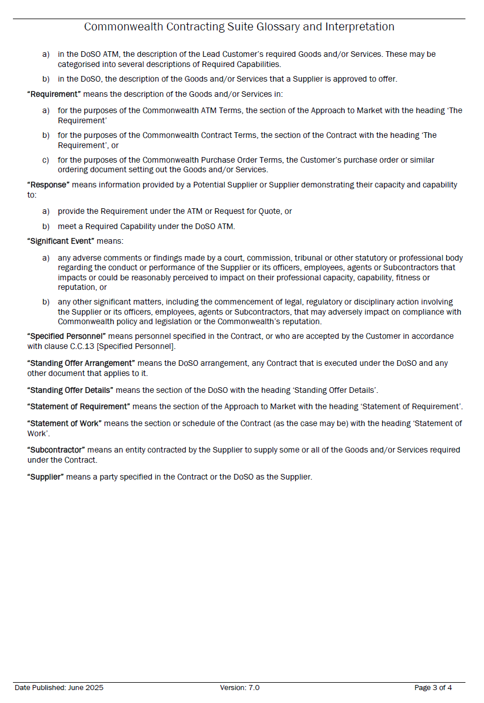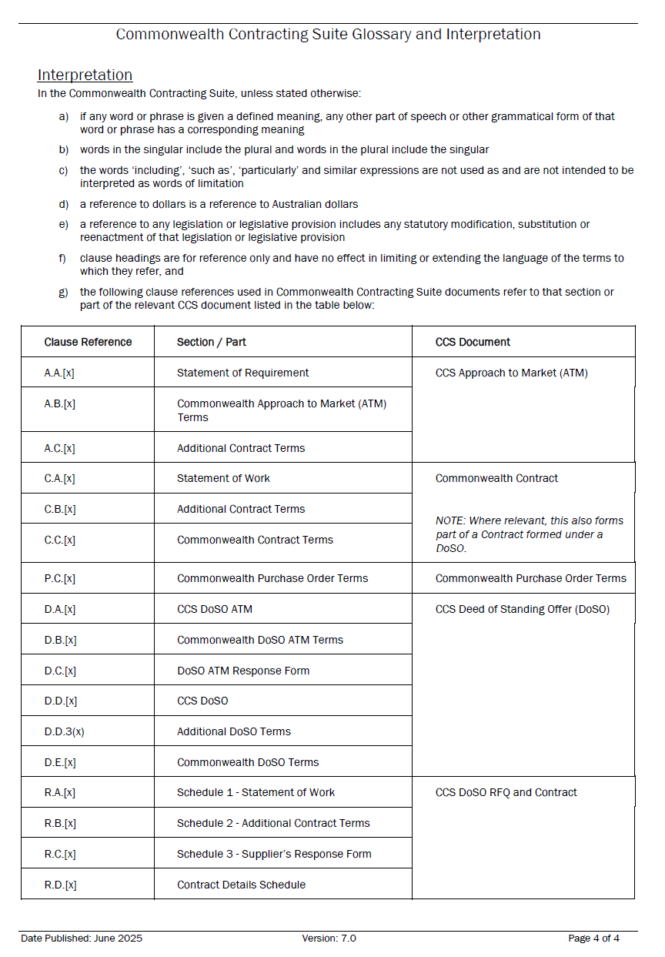
INSTRUCTIONS FOR POTENTIAL SUPPLIER
- Before you start
- This Response is not an offer for work.
- Read all the documentation provided by the Customer and distributed with this Response form and decide whether your organisation has the necessary skills and experience to meet the Customer’s requirement.
- Do not proceed further if:
  - your organisation cannot agree to the Commonwealth Contract Terms, available at https://www.finance.gov.au/government/procurement/commonwealth-contracting-suite-ccs. These terms are non-negotiable and will form part of the Contract if you are successful in this ATM process.
  - your organisation does not meet and/or agree to the Minimum Content and Format Requirements and the Conditions for Participation (if any), set out at item A.A.1 [Key Information and Dates], as failure to do so will mean your response cannot be considered.
  - your organisation is a trust where the Trustee is not empowered to sign contracts on behalf of the Trust. Before proceeding, contact the Customer’s ATM Contact Officer at item A.A.5(a) [ATM Contact Officer].
  - you are an Individual without an ABN and you do not meet the Australian Taxation Office’s (ATO) definition of an independent contractor available at: https://www.ato.gov.au/business/employee-or-contractor/how-to-work-it-out--employee-or-contractor. Before proceeding, contact the ATM Contact Officer set out at item A.A.5(a) [ATM Contact Officer] to seek advice.
- The Customer will evaluate all valid Responses received by the ATM Closing Time [Item A.A.1] that meet the Minimum Content and Format Requirements and the Conditions for Participation (if any), to determine which Potential Supplier has proposed the best value for money outcome for the Customer. Responses will be evaluated as per the criteria set out below:
Stage 1 - Tenders will be screened to identify those Tenders or Tenderers which have failed to comply with the Minimum Content and Format Requirements. If a Tenderer is excluded at the screening stage, the Tenderer will be promptly notified and offered an opportunity for a debriefing following approval from the delegate.
A Response may be excluded at any stage of the evaluation process if NCA identifies that it does not meet a Condition for Participation, Minimum Content and Format Requirement or other mandatory requirement.

NCA ATM Assessment
Stage 1: Screening |  | Compliant
1 | Conditions for Participation  The Customer will exclude from participation any Potential Supplier that does not demonstrate compliance with:  - The Respondent meets the definition of an Australian or New Zealand business  https://www.finance.gov.au/government/procurement/defining-australian-business-commonwealth-procurement/guidance-definition-australian-or-new-zealand-business | Yes □ No □
2 | Minimum Content and Format Requirements:  - lodge their Response as specified in the Statement of Requirement using the CCS ATM Response Form provided (if any) without changing the structure or formatting of the response form  - comply with any conditions for participation and ensure their Response complies with any minimum content and format requirements set out in the Statement of Requirement  - ensure the Response is in English, and  - ensure that prices quoted:  - are in Australian currency  - show the GST exclusive price, the GST component (if any) and the GST inclusive price  - are inclusive of GST and all other taxes, duties (including any customs duties) and any government charges imposed or levied in Australia or overseas, and  - unless identified in the Potential Supplier's Response, include any and all other charges and costs and be the maximum payable by the Customer under the Contract. | Yes □ No □

Stage 2 – NCA will evaluate Tenders that Comply with Stage 1 against the Weighted Evaluation criteria.
Item | Description | Weighting
Stage 2: Weighted Evaluation
3 | Ability to Meet the Requirements | 30%
4 | Demonstrated Capability and Capacity | 40%
5 | Previous Performance | 30%
Total |  | 100%

Stage 3 - The NCA will evaluate the information provided in the Tender against any risk inherent that have not already been evaluated which may include the following:

Stage 3: Risk Assessment |  | Risk Rating
6 | - Relevant Insurances and Workers Compensation  - Management Systems including Quality management, WHS management, Environmental management, and Risk management  - Licences, accreditation and certifications relevant to the services  - Information relating to Prohibition notices issued by ComCare or WorkSafe  - Referee Interviews/Reports  - Interview/Presentation  - Compliance with the draft contract

Stage 4 – Tenders will be evaluated against the unweighted criteria below taking into account the requirements provided by NCA using the required format (if applicable). Tenderers should provide clear and itemised pricing and detail the associated pricing mechanism, assumptions and caveats to allow NCA to form a clear understanding of the implications of the proposed solution on the whole-of-life costs to NCA.

Stage 4: Unweighted Criteria
7 | Price  The extent to which the Tenderer’s proposed fees, costs, allowances and charges associated with the delivery of the requirement contribute to a value for money outcome.

Stage 5 - Tenders will be evaluated to determine which Tender (if any) represents the best value for money for NCA, taking into account:
- the outcome of the assessment in Stage 2 – Weighted Evaluation Criteria
- the outcome of the assessment in Stage 3 - Risk assessment
- the outcome of the assessment in Stage 4 – Unweighted Criteria; and
- any other factors considered relevant by NCA in relation to value for money.

- Participation in this ATM is at your organisation’s risk and cost. Please note this is a competitive process and your organisation may incur costs in responding. If you are unsuccessful, you will be unable to recoup these costs.

- Format Requirements
- You MUST use this form (CCS ATM Response Form) to submit your Response, which MUST comply with the Commonwealth ATM Terms, available at: https://www.finance.gov.au/government/procurement/commonwealth-contracting-suite-ccs.
- As this form is set out to facilitate the evaluation of responses, Potential Suppliers are to use the form as provided and are not permitted to make any changes to the structure or formatting of the document.
- Guidance for completing your Response
- Specific questions about this ATM must be directed to the ATM Contact Officer set out at Item A.A.5(a) [ATM Contact Officer] before Question Closing Date and Time set out at item A.A.1 [Key Information and Dates].
- In preparation of this Response, please note the Commonwealth Indigenous Procurement Policy (IPP) available at: https://www.niaa.gov.au/indigenous-affairs/economic-development/indigenous-procurement-policy-ipp may apply to the Customer in respect of this procurement. During evaluation of responses, the Customer may consider the Supplier’s ability to assist the Customer to meet its IPP obligations.
- Ensure your Response is as concise as possible while including all information that your organisation wants the evaluation team to consider. Do not include general marketing material or assume that the evaluation team has any knowledge of your organisation’s capabilities or personnel.
- Do not include pricing in any other part of your response except in the relevant Pricing Schedule.
- The successful Supplier will have demonstrated its ability to provide the best value for the Customer. This will not necessarily be the lowest price.
- Submit the form as required by Item A.A.4 [Lodgement of Responses].
- If your organisation is unsuccessful with this Response, you may request a debrief to assist with future responses. The ATM Contact Officer set out at Item A.A.5(a) [ATM Contact Officer] can arrange this for you.
Drafting Note:
Before you finalise and submit your Response, please delete all Drafting Notes, including this entire section [Instructions for Potential Suppliers].
Do not type any information within the drafting note guidance tables as any drafting notes remaining in your Response may be removed by the Customer prior to evaluation.

Response to Approach to Market
to establish
Contract for Procurement of Scrivener Dam Independent Technical Advisor - 2026-2029
ATM Reference ID: A26/6

This Response will be prepared and lodged in accordance with the Minimum Content and Format requirements as set out in A.A.1 [Key Information and Dates]. | ☐ Yes  ☐ No: Do not proceed as your Response will not be eligible for further consideration
This Response will demonstrate our ability to meet the Conditions for Participation as set out in A.A.1 [Key Information and Dates]. | ☐ Yes  ☐ No: Do not proceed as your organisation will not have the ability to fulfil the requirements of the procurement.

Potential Supplier’s Contact Officer
For all matters relating to this Response, the Potential Supplier’s Contact Officer is:
Potential Supplier Name:
Contact Name:
Position:
Telephone:
Email Address:
Postal Address:
Part 1 – Potential Supplier’s Details
Drafting Note:
The following details will appear in the Contract should your Response be successful. The details you provide should be for the legal organisation that would be the Supplier under the Contract.
1.1 Potential Supplier’s Details
Organisation’s Full Legal Name: | Drafting Note:  Insert your organisation’s full legal name. If your organisation is successful in this ATM process, this will be the name of the Supplier for the Contract.
Legal Entity Type: | Individual/Sole Trader  Partnership  Company  Sole Director Company  Trust (see note below)  Educational Institution (see note below)  Other (please state):
NOTE FOR TRUSTS: If the Potential Supplier is trading as a trust, please provide details of the relevant trust (and trustee) including a copy of the relevant trust deed (including any variations to that deed) as an attachment to this Response.
NOTE FOR EDUCATIONAL INSTITUTIONS: If your Response is successful, prior to entering a Contract you will be required to provide details of any enabling legislation as well as details of any delegations or other authorisations that are relevant to the execution of a contract.
Australian Business Number (ABN): | Drafting Note:  If the Potential Supplier is an entity registered on the Australian Business Register, then the ABN used by the business must be given.
Australian Company Number (ACN): | Drafting Note:  If the Potential Supplier is an Australian company, then the ACN must be given.
Australian Registered Body Number (ARBN): | Drafting Note:  If the Potential Supplier’s business is an entity registered on the business names register kept under the law of a State or Territory of Australia, then each ARBN used by the business must be given in respect of each State or Territory of registration.
Registered Address: | Drafting Note:  Insert the supplier’s main business address as registered with the Australian Business Register.
1.2 Previous Judicial Decisions
Has your organisation, or where relevant any of its directors, ever had a judicial decision against them (not including decisions under appeal) relating to employee entitlements or engaged in practices that have been found to be dishonest, unethical or unsafe? | Yes, see below.  No
If yes, what was the date of discharge?  The Supplier acknowledges that the giving of false or misleading information to the Commonwealth is a serious offence under section 137.1 of the schedule to the Criminal Code Act 1995 (Cth). | (DD/MM/YYYY)  Note: The Customer cannot enter a contract with a supplier who has an undischarged judicial decision relating to employee entitlements.
1.3 Workplace Gender Equality
Is your organisation classified as a ‘relevant employer’ under the Workplace Gender Equality Act 2012 (the WGE Act)? See https://www.wgea.gov.au/about | Yes, I am a relevant employer  No, I am not a relevant employer
If yes, you are required to provide a current letter of compliance with the WGE Act prior to entering into a contract. Have you provided a letter of compliance with this Response? | Yes  No, I will provide a current letter of compliance prior to contract
NOTE: If the Potential Supplier is successful in this ATM process and where the Supplier is a relevant employer under the WGE Act, the Supplier must provide evidence that it complies with its obligations under the WGE Act before commencement of any Contract and, if the term is more than 18 months, within 18 months of commencement and annually thereafter for the duration of the Contract.
If the Supplier becomes non-compliant with the WGE Act during the course of the Contract, the Supplier must notify the Customer’s Contact Manager in writing within 10 Business Days. Compliance with the WGE Act does not relieve the Supplier from its responsibilities to comply with its obligations under the Contract.
1.4 Indigenous Businesses
Is your organisation:  - 50% or more Indigenous owned?  - a joint venture that is 50% or more indigenous owned which can demonstrate equal indigenous representation and involvement in the management of the joint venture? | Yes – see question below.  No – proceed to section 1.5.
Is your organisation registered on Supply Nation? | Yes  No – see note below  Not Applicable
NOTE: Please provide a certificate or letter from a recognised Indigenous organisation such as Land Council, Indigenous Ch Ability to Meet the Requirements of Commerce or Office of the Registrar of Indigenous Corporations verifying Indigenous ownership.
1.5 Australian Businesses
Is your organisation:  - a business, including any parent business, that:  - has 50% or more Australian ownership, or is principally traded on an Australian equities market; and  - is an Australian resident for tax purposes; and  - a business that has its principal place of business in Australia.  Further guidance is available at: www.finance.gov.au/australian-business. | Yes – see note below.  No – proceed to section 1.6.
NOTE: The Supplier acknowledges that the giving of false or misleading information to the Commonwealth is a serious offence under section 137.1 of the schedule to the Criminal Code Act 1995 (Cth). The Customer may request information from you to confirm your organisation meets the definition of Australian business.
1.6 New Zealand Businesses
Is your organisation a New Zealand Business as defined in New Zealand’s Government Procurement Rules, available at www.procurement.govt.nz | Yes – see note below.  No – proceed to section 1.7.
NOTE: The Supplier acknowledges that the giving of false or misleading information to the Commonwealth is a serious offence under section 137.1 of the schedule to the Criminal Code Act 1995 (Cth). The Customer may request information from you to confirm your organisation meets the definition of Australian business.
1.7 Potential Supplier’s Contract Manager
Drafting Note:
Provide details for the person you propose will be the Contact Manager if your Response is successful and your organisation is awarded a contract.

For matters relating to the proposed Contract, the Potential Supplier’s Contract Manager will be:
Name:
Position Title:
Telephone:
Mobile:
Email Address:
Postal Address:
1.8 Potential Supplier’s Address for Notices (if different from the Contract Manager)
Drafting Note:
Complete with “AS ABOVE” if same as Contact Manager.

Name:
Position Title:
Email Address:
Postal Address:

Part 2 – Executive Summary
2.1 Executive Summary of Potential Supplier’s Proposal
Drafting Note:
You may find it useful to complete this section after you have completed your response.
Provide a brief (less than one page) summary of your Response highlighting its key features. The Executive Summary should not merely replicate information provided elsewhere in your Response. This section brings together all aspects of your proposal and is your opportunity to “sell” its unique features.

2.2 Conditions for Participation
Drafting Note:
Respond to the Conditions for Participation here. Do not proceed further if you cannot meet the Conditions for Participation as your Response cannot be considered. The Customer will exclude from consideration any Response that does not meet the Conditions for Participation.
Include a statement about how your organisation meets the Conditions for Participation (if any) detailed at A.A.1 [Key Information and Dates].
If no Conditions for Participation specified, include the words: No Conditions for Participation specified.

Part 3 – Ability to Meet the Requirement
3.1 Detailed Proposal to Meet the Customer’s Requirement
Drafting Note:
Your response should address each aspect of the Statement of Requirement and explain/demonstrate how your response/solution meets the Requirement.
Provide a detailed description of your proposal to supply the Customer’s Requirement, including any delivery methodology. This is your opportunity to convince the evaluation team that your organisation understands the Requirement and can deliver it to a high standard. Do not provide general marketing material.
Highlight your competitive advantage as well as special or unique features of your proposal. Depending on the Requirement, your response may propose a detailed project plan including project milestones and completion dates, timeframes, quality standards or performance indicators. It may also detail critical issues or key delivery risks of which the Customer should be aware.
If meeting the Customer’s Requirement involves reporting, travel or attendance at meetings, you should clearly identify how you will meet these requirements, including details of personnel involved. Do not include any pricing or pricing information in Part 3. You should ensure that you clearly address any costs in your response to Part 6.
Do not rely on your organisation’s reputation. The evaluation team can only consider information you provide in this submission.
Tenderers are to limit their response to this section to 2,000 words or less.

- Commonwealth Supplier Code of Conduct
Drafting Note:
Where requested by the Customer at A.A.2(a), provide information demonstrating that you have appropriate policies, frameworks, or similar, in place to comply with the Commonwealth Supplier Code of Conduct. While you may include general information, try and focus your response to any specific aspects of the Code identified and any specific information requested above.
If A.A.2(a) does not specify compliance information, type “Not Applicable” below.

Has the Potential Supplier ever been investigated for a potential breach, or has been found to have actually breached, the Commonwealth Supplier Code of Conduct in connection with a Commonwealth contract? | ☐ Yes, see below.  ☐ No
If yes, provide further details:
Drafting Note:
Where requested by the Customer at A.A.2(a), provide information demonstrating that you have appropriate policies, frameworks, or similar, in place to comply with the Commonwealth Supplier Code of Conduct. While you may include general information, try and focus your response to any specific aspects of the Code identified and any specific information requested above.
If A.A.2(a) does not specify compliance information, type “Not Applicable” below.

- Standards
Drafting Note:
Provide full details and evidence of compliance with all applicable Australian standards, and any Australian and international standards and requirements specified in The Requirement. Potential Suppliers are encouraged to demonstrate how any standard(s) are proposed to be specifically used in the delivery of the goods/services (i.e. provide evidence that demonstrates how your organisation complies with applicable standards in the context of the requested goods/services and attach supporting evidence as necessary).
Where you do not propose to comply with a standard which has been included in The Requirement, propose an alternative standard and justify your reasons. Where no standard has been specified, list any applicable standards with which you propose to comply.
Type “Not Applicable” below if no standards apply.

Part 4 – Potential Supplier’s Demonstrated Capability and Capacity
4.1 Statement of Skills and Experience
Drafting Note:
This section should be used to demonstrate to the evaluation team your organisation’s proven capability and capacity to meet the Customer’s Requirement to a high standard and consistent quality. You should highlight your organisation’s capacity and any unique capabilities that provide it with a competitive advantage.
Provide clear, concise description of your organisation’s relevant skills and experience to deliver the Requirement.
Depending on the Requirement, this could include a detailed description of recent relevant experience in successfully supplying a similar requirement. It could also include your organisation’s expertise in this field, brief information on relevant personnel (highlighting relevant expertise and experience), details of relevant intellectual property or unique products used.
Do not include any pricing or pricing information in this Part. All pricing information should be included in Part 5.

Tenderers are to limit their response to this section to 1,000 words or less.

4.2 Specified Personnel
Drafting Note:
Only propose Specified Personnel where your proposal has referenced the skills of specific personnel and you reasonably expect them to perform the roles nominated. Include their role, the percentage of the project they will complete, and if relevant, their current Commonwealth Government security clearance. Add extra lines to the table as required.
You may also attach brief supporting information specific to the requirement including tailored CVs for Specified Personnel.
Where there are a number of staff who could perform a particular role, include details of the position/role and the percentage of project time which this role will perform. In these circumstances it would not be necessary to name the person.
Include details for subcontractor personnel if applicable. You will need to give additional details for subcontractors in the next section.
If no Specified Personnel are proposed, insert “Not Applicable”.

Name | Position/Role | CV Attached | Other Commitments | Commitment (%)
 |  | Y/N
 |  | Y/N
 |  | Y/N
 |  | Y/N
# If requested at A.A.2(b)

4.3 Subcontractors
Drafting Note:
The Customer may be required to publicly disclose information about subcontractors. Provide details for each subcontractor organisation you will use below.
In support of the Indigenous Procurement Policy (https://www.niaa.gov.au/indigenous-affairs/economic-development/indigenous-procurement-policy-ipp), also highlight any Indigenous subcontractors you are proposing to use, or any Indigenous staff who will work on the project.
If no subcontractors are proposed insert “Not Applicable”

Full Legal Name:
Postal Address:
ABN/ACN/ARBN:
Is this subcontractor registered on Supply Nation or 50% or more Indigenous owned?

  - Scope of Works to be Subcontracted
Drafting Note:
If no subcontractors are proposed insert “Not Applicable”.
Provide details of the roles (or specific parts of the contract) each subcontractor will perform.
The Supplier is solely responsible for all obligations under the Contract, including subcontractor performance and management. The Supplier must ensure that any subcontract arrangement that is entered into imposes necessary obligations on the subcontractor.
If you are intending to include subcontractors, read and understand your obligations under the Commonwealth Contract Terms, Subcontracting [Clause C.C.10], Relationship of the Parties [Clause C.C.2], Compliance with the Laws and Policy [Clause C.C.21] specifically relate to subcontractors.

4.4 Conflicts of Interest
Drafting Note:
Commonwealth officials have an obligation to disclose Conflicts of Interest under section 29 of the Public Governance, Performance and Accountability Act 2013 (Cth). Suppliers to Commonwealth entities need to assist the Commonwealth to meet its obligations by complying with the same standard of conduct.
Conflicts can be real or apparent. The perception of a conflict can be just as damaging to the public’s confidence in public administration as an actual conflict based on objective facts.
Provide full details of any Conflicts of Interest (if any) that could arise as a result of entering into the Contract with a Customer and propose a strategy to manage the conflict. For complex issues, you may choose to attach a Conflict of Interest Management Plan detailing your proposed approach.
After this response is submitted, Potential Suppliers must report any Conflicts of Interest that may have arisen or been identified during the evaluation period to the Customer without delay.
If no Conflicts of Interest were identified, type “Nil”.
The Potential Supplier has identified the following potential Conflicts of Interest and management strategies:
Details | Management Strategy
4.5 Pre-existing Intellectual Property of Potential Supplier
Drafting Note:
List your pre-existing Intellectual Property (if any) noting that:
The Supplier grants to, or in the case of Third-Party Material, must obtain for, the Customer a non-exclusive, irrevocable, royalty-free, perpetual, world-wide licence (including the right to sub-licence) to exercise the Intellectual Property Rights in all Pre-existing Material and Third- Party Material incorporated into the Material to enable the Customer to receive the full benefit of the Goods and/or Services and the Material and to exercise its rights in relation to the Material.
If no pre-existing Intellectual Property is proposed insert “Not Applicable”.

4.6 Confidentiality of Potential Supplier’s Information
Drafting Note:
Identify any information in your Response, or the proposed Contract, which you consider should be kept confidential, with reason(s).
The Customer will only agree to treat information as confidential in cases that meet the Commonwealth’s guidelines and which the Customer considers appropriate. If the Customer does not agree that the information meets the guidelines to be treated as confidential, the Customer has the right to disclose any information contained in the Contract.
Information to assist you to assess whether the Customer is able to treat particular information as confidential is available at: https://www.finance.gov.au/publications/resource-management-guides/procurement-publishing-and-reporting-obligations-rmg-423.
If none, type “Not Applicable”.
Add extra lines to the table as required.
The Potential Supplier has assessed that the commercial information in the table below meets the requirements available at https://www.finance.gov.au/government/procurement/buying-australian-government/additional-reporting-confidentiality and is seeking that information be kept confidential.
Information to be kept Confidential | Reasons for Confidentiality Request

Part 5 – Previous Performance

5.1 Previous Performance
Drafting Note:
Please provide details of past performance for your last three (3) completed projects that are directly relevant to Independent Technical Advisory services for dam infrastructure. For each project, include the project name, client, completion date, a brief description of the scope of services, and your role and key responsibilities. Respondents must provide evidence of project performance against agreed time, cost, and quality objectives, including achievement of key milestones, quality outcomes, and delivery within the approved budget. Where applicable, identify any delays, variations, or significant project issues, including a brief explanation of the cause, impact, and management approach. Respondents should also provide any supporting documentation or attachments (e.g. performance reports, client references, completion reports, KPI reports, or similar evidence) to substantiate the stated outcomes and performance.
Do not include any pricing or cost information in this section. All pricing must be submitted separately in Part 6.
Tenderers are to limit their response to this section to 2,000 words or less.

5.2 Referees
Drafting Note:
Provide daytime contact details for three (3) referees who can attest to your capacity to meet the Requirement. You may prefer to include details of referees for Specified Personnel. A reference is stronger if your organisation and/or Specified Personnel has recently provided the referee with similar goods/services. It is good practice to ensure that nominated referees are aware they may be contacted.
Note clause A.B.5 [Evaluation]: The Customer reserves the right to contact any referees, or any other person, directly and without notifying the Potential Supplier.
NCA personnel are not permitted as referees.

Referee Name | Position | Organisation | Phone Number |  | Email Address | Reference Project Name

Part 6 – Total Costs to be incurred by the Customer
Drafting Note:
The information you provide in this section will be used to assess the total costs the Customer will incur under your proposal.
6.1 Pricing
Fixed Price (including all expenses)

Drafting Note:
Complete the following table including fixed prices for each item. Fixed prices must include taxes, duties and other government charges which may be imposed or levied in Australia and overseas, and all other costs associated with providing the services, including delivery fees where applicable.
Make sure you include, costs of any reporting and attending necessary meeting as well as any travel, accommodation and associated costs.
Add additional lines to the table as required.

Item | Milestone Description | Total Price  GST Exclusive | GST Component | Total Price  GST Inclusive
1 | 2026-2027 (Annual Validation Audit)
2 | 2027-2028 (Annual Validation Audit)
3 | 2028-2029 (5 -Year Functional Audit / Annual Validation Audit)
4 | Ad Hoc Advisory Services (Provisional Sum) | $13,636.36 | $1,363.64 | $15,000.00
Adjustment to Fixed Pricing for Contract Variation/Extension
Drafting Note:
Explain how the above pricing would be adjusted, if a contract variation (for either an increase or decrease in the Requirement) was requested.
For example, if the contract is for a one-year period, what would the rates be in the second year? If the quantity of goods increased or decreased what would be the effect on price?
Contract Extension Option
Item | Description |  | Total Price  GST Exclusive | GST Component | Total Price  GST Inclusive
1 | 2029-2030 (Annual Validation Audit)

6.2 Schedule of Rates*
Drafting Note:
Please provide a Schedule of Rates that includes all personnel resources required for the delivery of services under this procurement. The Schedule of Rates must:
- List all personnel categories/roles proposed for this engagement (e.g., project managers, engineers, technicians, administrators, etc.).
- Include the hourly rates for each role.
- Ensure all rates are GST inclusive
Add additional lines to the table as required.

Role | Name | 2026-2027 FY Rate $/hr (inc. GST) | 2027-2028 FY Rate $/hr (inc. GST) | 2028-2029 FY Rate $/hr (inc. GST)
Adjustment to Fixed Pricing for Contract Variation/Extension
Drafting Note:
Explain how the above pricing would be adjusted, if a contract variation (for either an increase or decrease in the Requirement) was requested.
For example, if the contract is for a one-year period, what would the rates be in the second year? If the quantity of goods increased or decreased what would be the effect on price?
The Schedule of Rates must:
- List all personnel categories/roles proposed for this engagement (e.g., project managers, engineers, technicians, administrators, etc.).
- Include the hourly rates for each role.
- Ensure all rates are GST inclusive

Role | Name | 2029-2030 FY Rate $/hr (inc. GST)
* Payment for contract variations will be determined using the Schedule of Rates and provision of a fixed price quotation, or as agreed with Customer.

6.3 Proposed Payment Schedule
Drafting Note:
Complete the table below if you propose that progress payments be made.
Do not propose a payment schedule that reflects more than the value of the milestones or deliverables you have delivered at any stage.
This payment schedule is for the Fixed Fees and Charges portion of the arrangement only. Variable costs will only be reimbursed after they have been incurred and invoiced.
Note: The Customer may propose alternative payment arrangements.
If you are not proposing any progress payments type “Not Applicable”.

Due Date | Milestone Description | Total Price  (GST Exclusive) | GST Component | Total Price  (GST Inclusive)
31/08/2027 | 2026-2027 (Annual Validation Audit)
31/08/2028 | 2027-2028 (Annual Validation Audit)
31/08/2029 | 2028-2029 (5 -Year Functional Audit / Annual Validation Audit)
Total Milestone Payments

6.4 Additional Facilities and Assistance
Drafting Note:
Should you require the Customer to provide facilities and assistance, in addition to that stated at Clause A.A.2(f) [Facilities and Assistance Offered by the Customer], provide details here. If no additional facilities or assistance required insert “Not Applicable”.
If the pricing provided above is based on the provision of Additional Facilities and Assistance this should be stated below.

6.5 Non-Compliance
Drafting Note:
If your response is successful, you will be offered a Contract which incorporates the Commonwealth Contract Terms available at https://www.finance.gov.au/government/procurement/commonwealth-contracting-suite-ccs. The Terms have been designed to enable Commonwealth officials to comply with their legislated responsibilities and are therefore NOT negotiable.
If you have reasons why any of the Additional Contract Terms should be changed, complete the following table, as these additional terms may be negotiable.
Any costs the Customer would incur in obtaining legal advice (including in-house legal advice) or negotiating the Customer’s Additional Contract Terms will be included in the Customer’s total costs assessment.

Clause | Reason for Non-Compliance | Proposed New Wording

